Problem Set 6 – Multiple Regression Part III

Problem 1 (35 points)
Please access the Kansas City House Price dataset. This dataset, from Kaggle, contains house sale prices for King County, which includes Seattle. It includes homes sold between May 2014 and May 2015. The license agreement was listed as public domain.

We are interested in the following variables:

Response: Price (sale price of house, dollars)
Regressors:
- Bedrooms (number of)
- Bathrooms (number of)
- Sqft_lot (size of lot, ft²)
- Floors (number of)
- Condition (on scale of 1 to 5)
- Grade (An index from 1 to 13, where 1-3 falls short of building construction and design, 7 has an average level of construction and design, and 11-13 have a high-quality level of construction and design.)
- Lat (latitude)
- Long (longitude)
- Sqft_living (amount of living space, ft²)

Please answer each of the following questions. So that your answers remain focused, you are to include ONLY the item(s) requested (else, your earned credit will be reduced).

- (3 points) Use JMP to regress Price on the nine regressors. Make sure they are entered in the order they are shown here. Do not use any transformations. Record here the sequential sums of squares value for “floors”.

Full Model
Regressor | Sequential Sums of Squares
FLOORS | 540549027

- (3 points) Use JMP to regress Price on Bedrooms, Bathrooms, Sqft_lot, and Floors. Copy and paste the Analysis of Variance Table in the space below.

Source | DF | Sum of Squares | Mean Square | F Ratio
Model | 4 | 8.1461e+14 | 2.037e+14 | 2097.193
Error | 21608 | 2.0983e+15 | 9.711e+10 | Prob > F
C. Total | 21612 | 2.9129e+15 |  | <.0001*

- (3 points) Use JMP to regress Price on Bedrooms, Bathrooms, and Sqft_lot. Copy and paste the Analysis of Variance Table in the space below.

Source | DF | Sum of Squares | Mean Square | F Ratio
Model | 3 | 8.1461e+14 | 2.715e+14 | 2796.384
Error | 21609 | 2.0983e+15 | 9.71e+10 | Prob > F
C. Total | 21612 | 2.9129e+15 |  | <.0001*

- (7 points) In three sentences or less, explain how you can get the answer in part a. from information in the tables you posted in parts b and c.

The Sequential Sum of Squares for Floors is calculated by subtracting the Model Sum of Squares in part (c) from the Model Sum of Squares in part (b). This difference represents the additional variation in Price explained by adding Floors after Bedrooms, Bathrooms, and Sqft_lot. The result is 540,549,027, although the rounded ANOVA tables do not show this small difference.

- (3 points) Use JMP to regress Price on the nine regressors. Make sure they are entered in the order they are shown here. Do not use any transformations. Copy and paste here the Effects Test table and the Sequential (Type 1) Tests table.

Source | Nparm | DF | Seq SS | F Ratio | Prob > F
bedrooms | 1 | 1 | 2.7696e+14 | 5530.453 | <.0001*
bathrooms | 1 | 1 | 5.319e+14 | 10621.23 | <.0001*
sqft_lot | 1 | 1 | 5.7565e+12 | 114.9481 | <.0001*
floors | 1 | 1 | 540549027 | 0.0108 | 0.9173
condition | 1 | 1 | 2.9793e+13 | 594.9310 | <.0001*
grade | 1 | 1 | 5.5557e+14 | 11094.00 | <.0001*
lat | 1 | 1 | 1.736e+14 | 3466.494 | <.0001*
long | 1 | 1 | 2.3642e+13 | 472.1006 | <.0001*
sqft_living | 1 | 1 | 2.3384e+14 | 4669.466 | <.0001*

Source | Nparm | DF | Sum of Squares | F Ratio | Prob > F
bedrooms | 1 | 1 | 2.0307e+13 | 405.5062 | <.0001*
bathrooms | 1 | 1 | 2.0495e+10 | 0.4093 | 0.5224
sqft_lot | 1 | 1 | 1.8318e+11 | 3.6578 | 0.0558
floors | 1 | 1 | 2.2093e+12 | 44.1158 | <.0001*
condition | 1 | 1 | 2.5665e+13 | 512.4975 | <.0001*
grade | 1 | 1 | 9.0886e+13 | 1814.859 | <.0001*
lat | 1 | 1 | 1.4751e+14 | 2945.590 | <.0001*
long | 1 | 1 | 3.4524e+13 | 689.3890 | <.0001*
sqft_living | 1 | 1 | 2.3384e+14 | 4669.466 | <.0001*

- (5 points) Refer to part e. The Effect Tests table shows “bathrooms” as being an insignificant predictor. Identify the hypothesis being tested there. Only one of the possible answers shown below is reasonable. Place an “X” in the box to the immediate left of your chosen answer.

Problem 1f: Solution Choices
 | “Is Bedrooms needed as a regressor, now that Bathrooms has entered the model?”
 | “Is Bathrooms an important regressor?”
 | “Is Bathrooms needed as a regressor, given Bedrooms is already in the model?”
x | “Is Bathrooms needed as a regressor, in the presence of all the other regressors?”

- (5 points) The Sequential (Type 1) Tests table shows “bathrooms” as being a significant predictor. Identify the hypothesis being tested there. Only one of the possible answers shown below is reasonable. Place an “X” in the box to the immediate left of your chosen answer.

Problem 1g: Solution Choices
 | “Is Bedrooms needed as a regressor, now that Bathrooms has entered the model?”
 | “Is Bathrooms an important regressor?”
x | “Is Bathrooms needed as a regressor, given Bedrooms is already in the model?”
 | “Is Bathrooms needed as a regressor, in the presence of all the other regressors?”

- (6 points) A colleague in your department knows you have some statistical training, so they ask you the following question regarding this model. “Can I use the Effect Tests table sums of squares to apportion the amount of variability explained by the model, that can specifically be attributed to floors”? In three sentences or less, answer their question.

No, the Effect Tests sums of squares cannot be used to apportion the model's explained variability because the regressors may explain overlapping variation in Price. Effect Tests measure the unique contribution of each variable after accounting for all other regressors. Sequential sums of squares can be used to partition the explained variability, but the amounts depend on the order in which variables enter the model.

Problem 2 (15 points)
Please revisit the Kansas City House Price dataset. This dataset, from Kaggle, contains house sale prices for King County, which includes Seattle. It includes homes sold between May 2014 and May 2015. The license agreement was listed as public domain. We are interested in the following variables:

Response: Price (sale price of house, dollars)
Regressors:
- Bedrooms (number of)
- Bathrooms (number of)
- Sqft_lot (size of lot, ft²)
- Floors (number of)
- Condition (on scale of 1 to 5)
- Grade (An index from 1 to 13, where 1-3 falls short of building construction and design, 7 has an average level of construction and design, and 11-13 have a high-quality level of construction and design.)
- Lat (latitude)
- Long (longitude)
- Sqft_living (amount of living space, ft²)

We did the following:
- JMP was used to regress Price on the nine regressors, and the nine sequential sums of squares were scaled to be less than 1 and recorded.
- Sequentially, as the models included more and more variables, the value of PRESS R² was recorded at each stage.
- The scaled sequential sums of squares and PRESS R² values were plotted on the same set of axes and that plot is shown below.

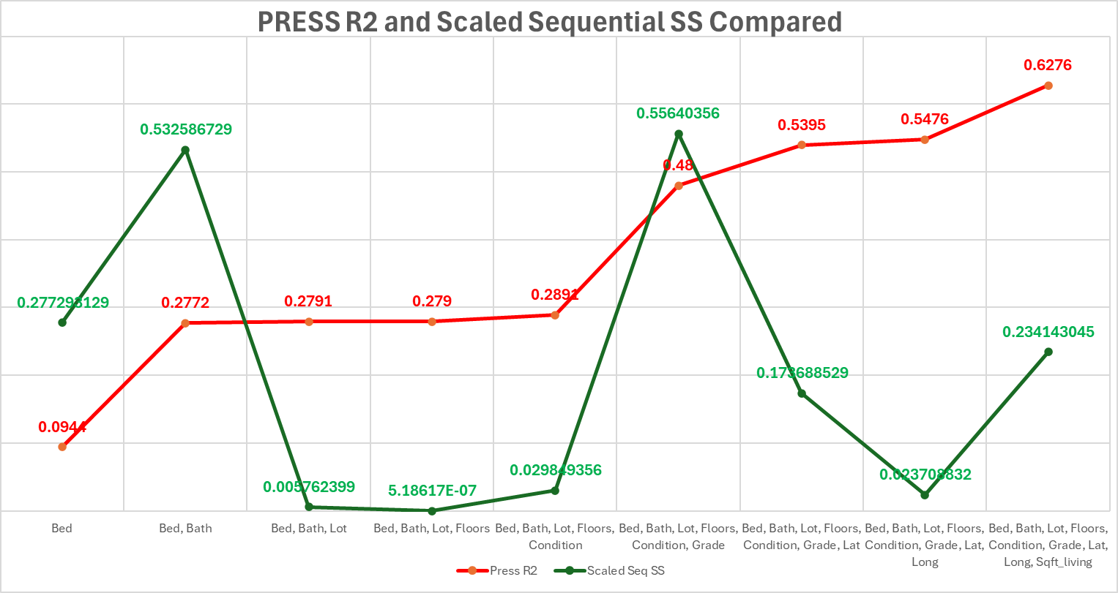

- (7 points) Refer to the plot above. Assume we are building a model sequentially, starting with Bed and then adding regressors in the order listed. In three sentences or less, explain how the PRESS R2 curve and the scaled Sequential Sums of Squares curve are perfectly complimentary with the information they are conveying in that construction.

The Sequential Sums of Squares show how much additional variation each regressor explains as it enters the model. PRESS R² shows how the model's predictive ability changes as additional regressors are included. Together, they show whether adding a variable improves the model's explanatory power and predictive performance.

- (8 points) Look only at the scaled Sequential Sums of Squares curve in the plot above. Identify a four-variable model that that this plot suggests would be good from those available for predicting Price. In three sentences or less, defend your answer.

A four-variable model consisting of Bedrooms, Bathrooms, Grade, and Sqft_living would be a good choice for predicting house prices. These variables have the largest scaled Sequential Sums of Squares, indicating that they explain the greatest additional variation in Price when entered in the order shown. The remaining variables contribute relatively little additional explanatory power.

